#### Lab - How to create a Core eDiscovery Case?

Step 1: Navigate to the Security and Compliance center.

Step 2: Click “eDiscovery” under the “eDiscovery” select standard on the navigation menu on the left-hand side of the screen.

Step 3: Type a case name and a description (optional) and click “Save”

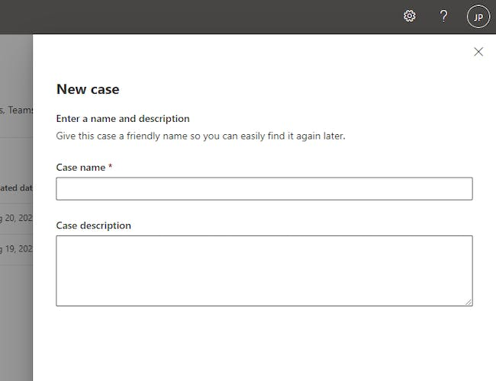

Step 4: Select the case to navigate to the case page and take further action.

